Standby for Start-up!
A suite of practical and interactive workshops to get your business off to the right start. We run them every month, so please get in touch to find out the next available dates!
- Introduction to self employment
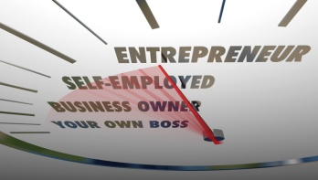
This workshop is designed to give you an insight into all aspects of
self-employment.
Explains the issues and challenges involved before taking the
plunge and launching your venture.

Monday 10am to 1pm

- Business planning
A step by step guide to writing a business plan.
Thursday 10am to 1pm

- Financials
The bottom line – understanding cash flow and profit.
Monday 10am to 1pm

- Marketing
Getting your marketing right to maximise sales.
Thursday 10am to 1pm

These workshops are fully funded however booking is essential. To find out the next available dates and book your place please ring us on 01388 776688 or email colin@theenterpriseagency.co.uk or send us a message on
Facebook South Durham Enterprise Agency

